

RapidDeploy Whitelisting Requirements

Have your IT Department add *rapiddeploy.com* to your whitelist of IP addresses. Whitelisting helps ensure important resources and customer updates from RapidDeploy, such as product releases and quarterly customer updates, will be received by your agency.

See examples below of content you will be receiving periodically:

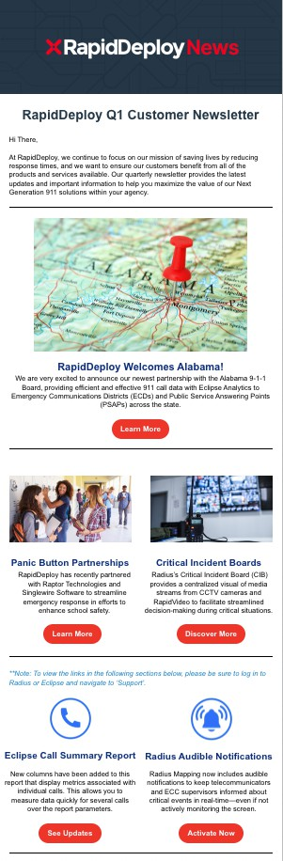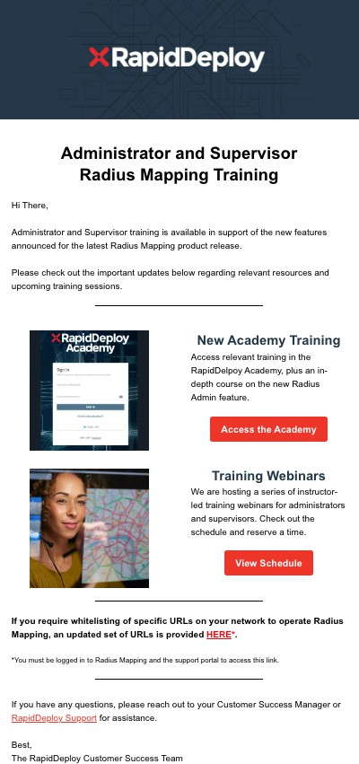

RapidDeploy, Inc. | 310 Comal Street, Building A, Suite 200, #205, Austin, TX 78702 | rapiddeploy.com

**Proprietary and Confidential**